WIDE BAND
DIRECTIONAL COUPLER

Specification:
- frequency range: 50Mhz-2500Mhz
- coupling loss: 20 +/- 3 dB
- return loss: 20 dB min
- directivity: 26 dB min @ <500Mhz
22 dB min @ >500Mhz
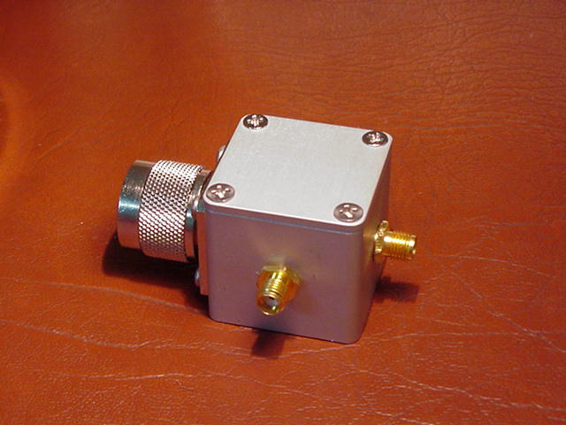
2003/7/25
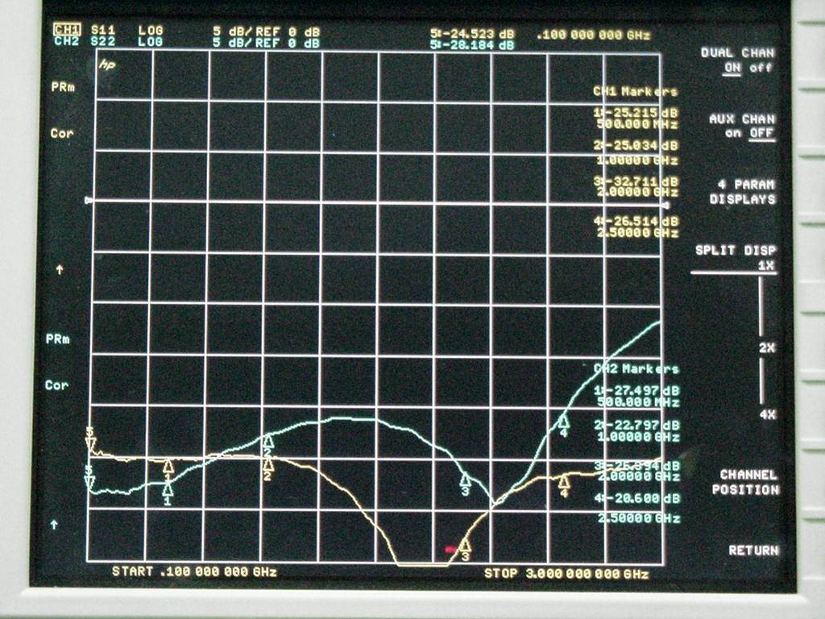
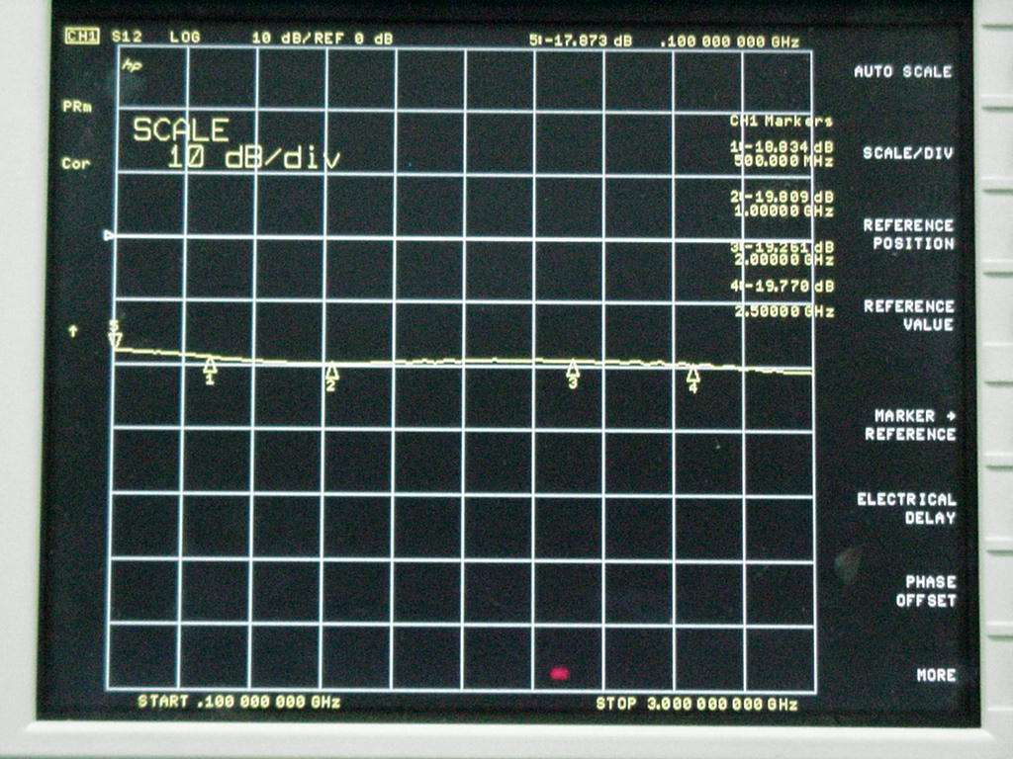
Fig1. Return loss of input S11 and coupling S22 ports.
Fig2. Coupling loss between input and coupling ports.
( ps: the output port is terminated in fig1., and opened in fig2.)

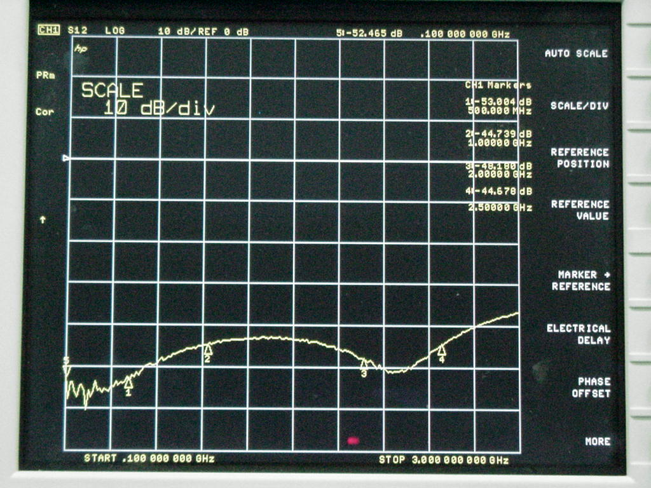
Fig3. Coupling loss when output (test) port terminated.
thus, directivity = loss (fig2) – loss (fig3)

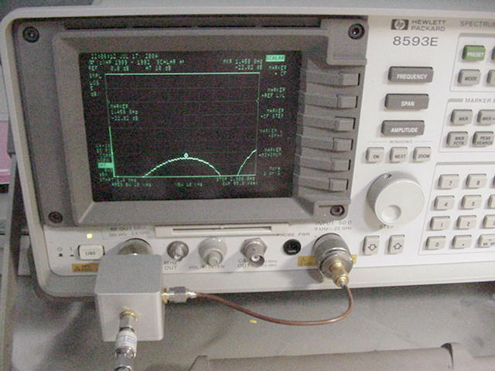
Fig4. Connect directional coupler with HP8593E which has TG.

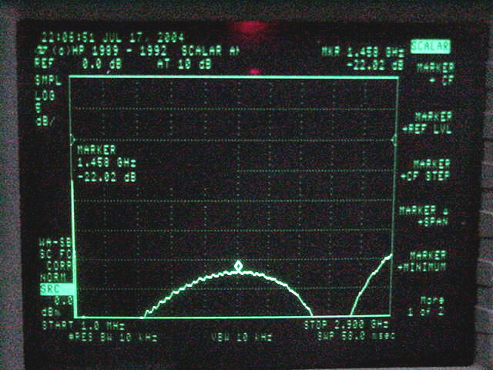
Fig5. The measured return loss with the output (test) port terminated
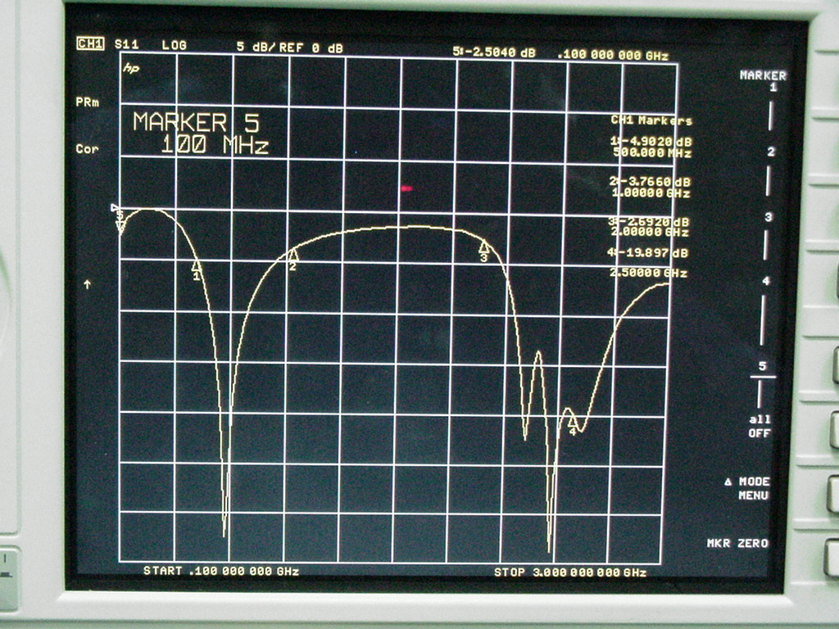
Fig6. Antenna’s return loss measured on network analyzer straightly.
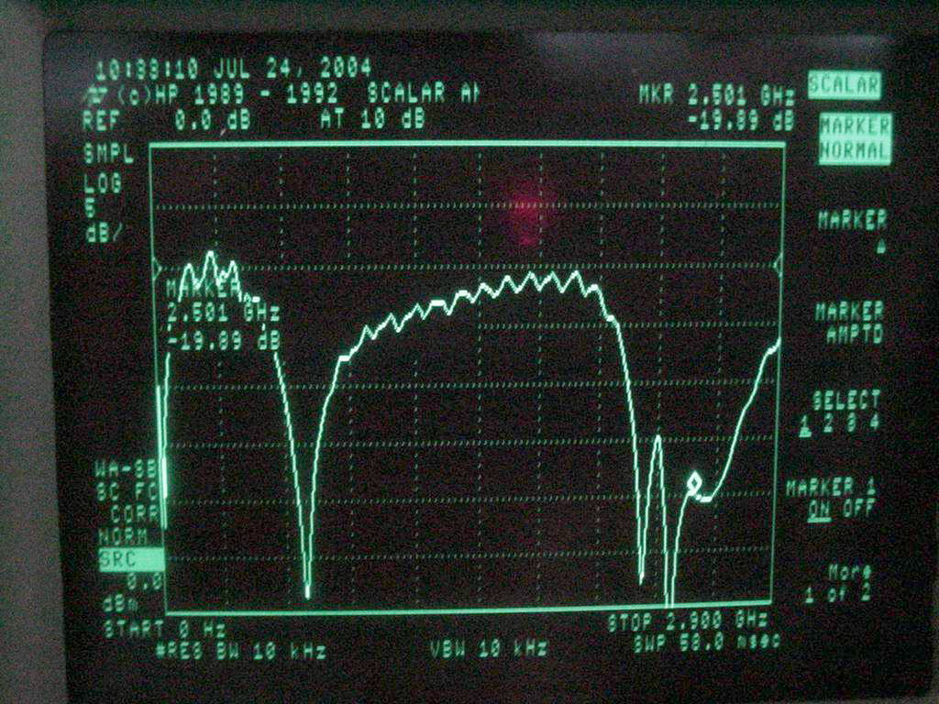
Fig7. Antenna’s return loss measured on spectrum through the directional coupler.

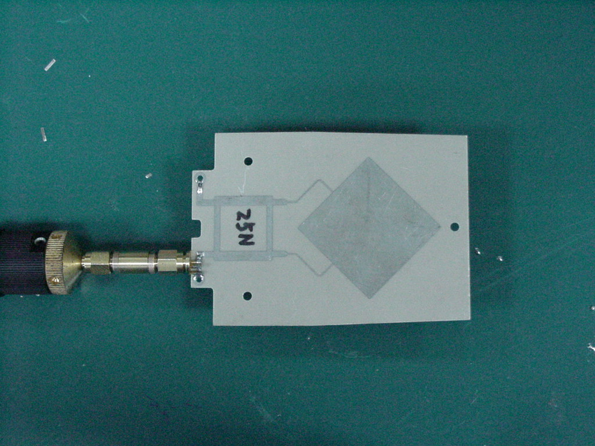
Fig8. The antenna (2.4Ghz) is in measuring.

